SARDAR VALLABHBHAI NATIONAL INSTITUTE OF TECHNOLOGY, SURAT
DEPARTMENT OF CIVIL ENGINEERING
WATER RESOURCES ENGINEERING SECTION
WATER RESOURCES ENGINEERING LABORATORY
Water resources engineering (WRE) laboratory was established in the year 1961. The laboratory is located behind the Department of Civil Engineering. The laboratory facilities are utilized by undergraduate and postgraduate students for their curriculum laboratory work. The research scholars also utilize it for the research and development activities. Set ups like groundwater modeling, cavitation studies and open channel are used for some of the consultancy work. It is one of the key laboratory for UG/PG courses working with majority of available set ups. The laboratory has good potential to carry out research and generate revenue using calibration and testing work in future. List of equipments available in the laboratory is given below:
Sr. No. | Equipment Name
1 | Wind Tunnel Equipment With Auto Model A8
2 | Hele Shaw Apparatus
3 | Infiltrometer
4 | Multipurpose Flume
5 | Pipe Surge and Water Hammer Apparatus
6 | Ground Flow/Well Abstraction
7 | Hydraulic Bench
8 | Basic Hydrology System/ Rainfall Simulator
9 | Pipe Fitting
10 | Orifice and Mouthpiece
11 | Notch Apparatus
12 | Reynolds Apparatus
13 | Bend Meter
14 | Rota Meter
15 | Bernoulli’s Theorem
16 | Friction in Pipeline
17 | Metacentric Height
18 | Impact on Jets
19 | Nozzle Meter
20 | Pitot Static Tube
21 | Venturimeter and Orifice Meter
22 | Free And Force Vortex Apparatus
23 | Current Meter
24 | Double Ring Infiltrometer
25 | Electrical Analogy Apparatus
26 | Specialized Software
Information Regarding Few Important Set Ups in the WRE Laboratory
Multipurpose Flume:
The set-up comprises of a rectangular tilting flume. The water is generally supplied by a centrifugal pump. At the inlet and the exit sections for flow control, gates with rack and pinion arrangements are provided. The flume inlet portion is equipped with a honeycomb or baffles wall to calm the flow. On top of the side walls, the flume is provided with rails on which a trolley moves to and fro. The trolley is equipped with the pitot-static tube and the pointer gauge. The flume can be tilted to give the required slope with a screw jack provided for this purpose. A calibrated orifice meter is provided on the supply line for discharge measurement. Alternatively, a large measuring tank can collect water. Multipurpose flume is shown in figure 1 below.
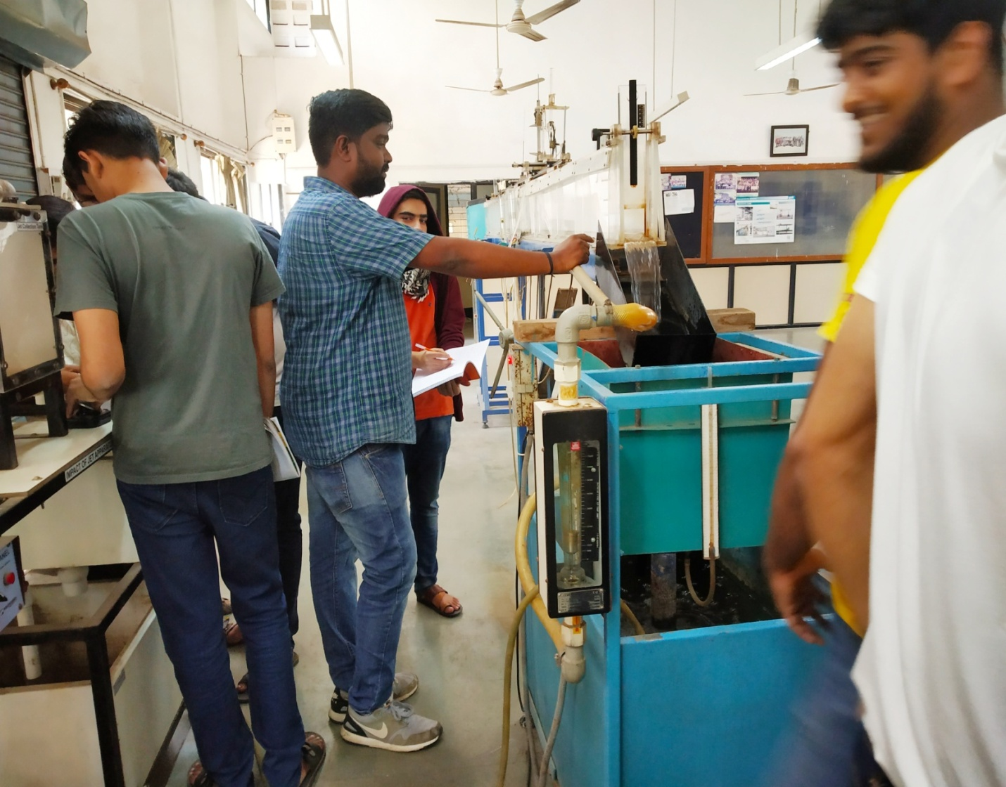
Figure.1 Multipurpose Flume
Basic Hydrology System/ Rainfall Simulator:
Basic Hydrology System is a laboratory instrument by which we can measure the run-off discharge, base flow discharge by adjusting rainfall intensity. For equally distributing rainfall over the bed, nine showers are fitted at equal distances from each other. The rainfall simulator is shown below in figure 2.
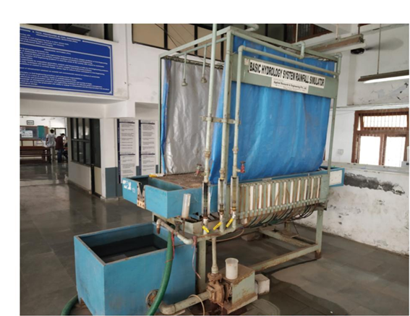
Figure.2 Basic Hydrology Simulator

LIST OF EXPERIMENTS
Hydraulic Engineering (CE201) (B. Tech-II (Civil), Semester III)
Sr. No. | Title of Experiment
1 | Determination of metacentric height
2 | Estimation of hydraulic coefficients for orifice
3 | Calibration of rectangular and triangular notches
4 | Calibration of venturi meter and orifice meter
5 | Verification of Bernoulli’s principle
6 | Friction factor of laminar and turbulent flow for single and multiple pipes
7 | Characteristics of free and forced vortex
8 | Measurement of velocity distribution using pitot tube and current meter
9 | Development of specific energy diagram
10 | Characteristics of hydraulic jump
11 | Main characteristics of turbines
12 | Operating characteristics of centrifugal pump

LIST OF EXPERIMENTS
Hydraulic Engineering Laboratory-1 (CEWR105) (M. Tech-I (Civil), Semester I)
Sr. No. | Title of Experiment
1 | Development of uniform flow in open channel
2 | Measurement of velocity distribution in open channel using pitot tube and plotting of isovels and computation of α and β
3 | Establishment of subcritical, critical and supercritical flow in open channel, plotting of specific energy diagram
4 | Characteristics of hydraulic jump in open channel
5 | Measurement and computation of gradually varied flow profiles in open channel
6 | Rainfall and runoff characteristics using rainfall simulator
7 | Infiltrometer to study infiltration capacity of different types of soil
8 | Measurement of boundary layer thickness on flat plate
9 | Measurement of drag and lift force coefficient for cylinder and spheres
10 | Development of synthetic unit hydrograph and flood hydrograph using CWC method

LIST OF EXPERIMENTS
Hydraulic Engineering Laboratory-II (CEWR204) (M. Tech-I (Civil), Semester II)
Sr. No. | Title of Experiment
1 | Measurement of discharge using Venturi flume for free and submerged flow condition
2 | Measurement of discharge using Broad-crested weir for free and submerged condition
3 | Incipient motion of sediments in mobile boundary channel
4 | Flow through porous media using ground water flow unit
5 | Measurement of bed shear stress by preston tube
6 | Seepage analysis of earthen dam using electrical analogy
7 | Water hammer pressure and surge tank analysis
8 | Cavitation demonstration and analysis

Photos of Some Other UG/PG Set Ups
METACENTRIC HEIGHT APPARATUS
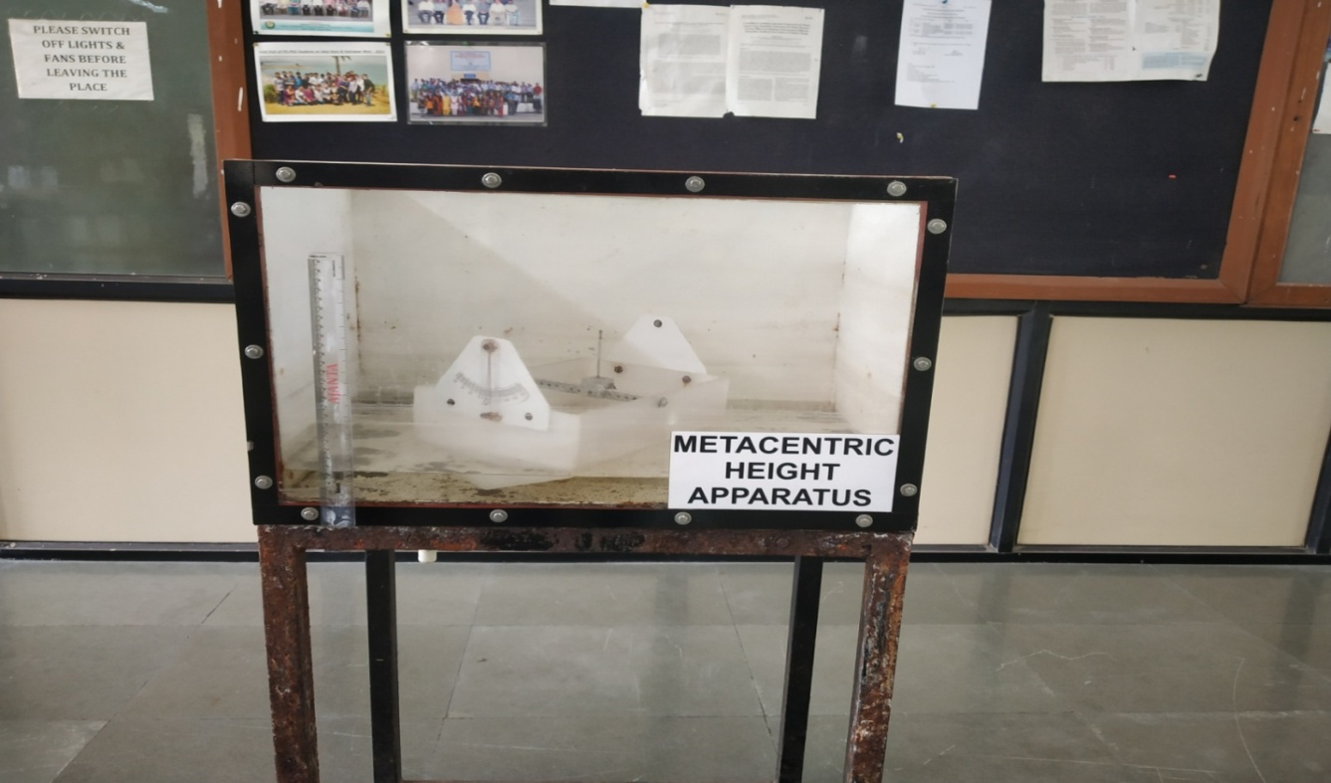
BERNOULLIS THEORAM APPARATUS
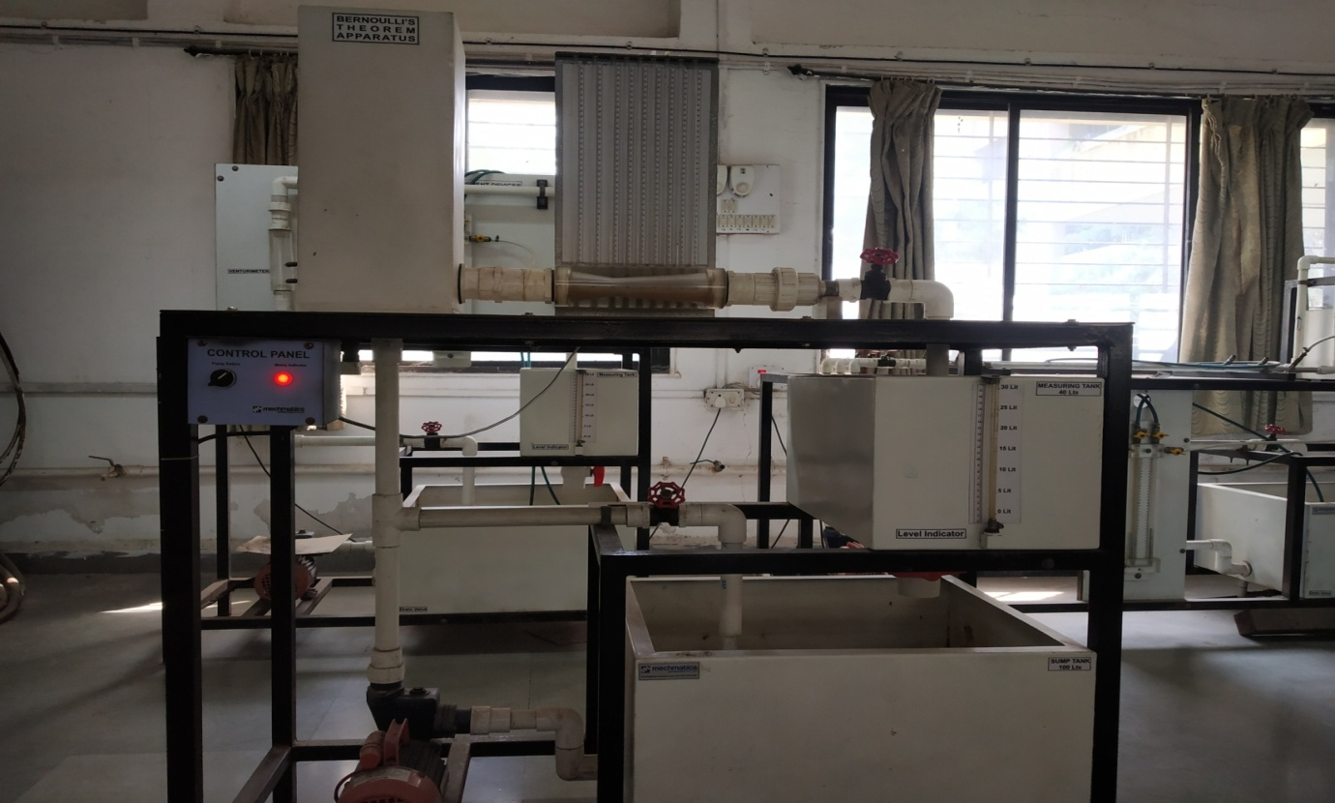
NOTCH APPRATUS
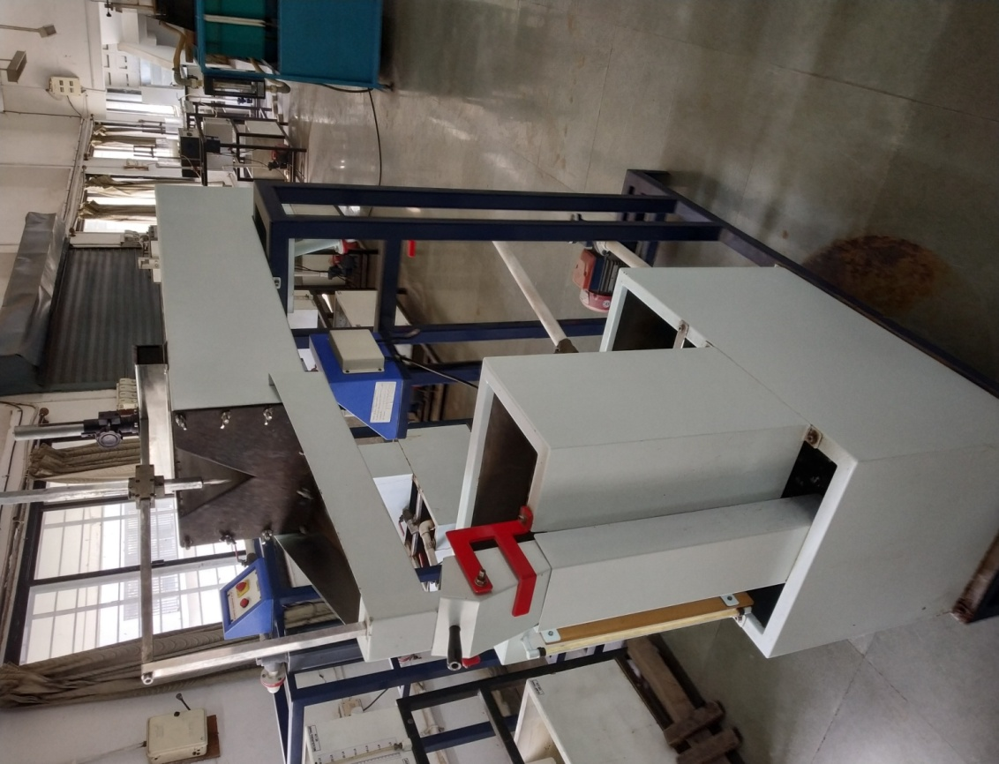
FORCED VORTEX APPARATUS
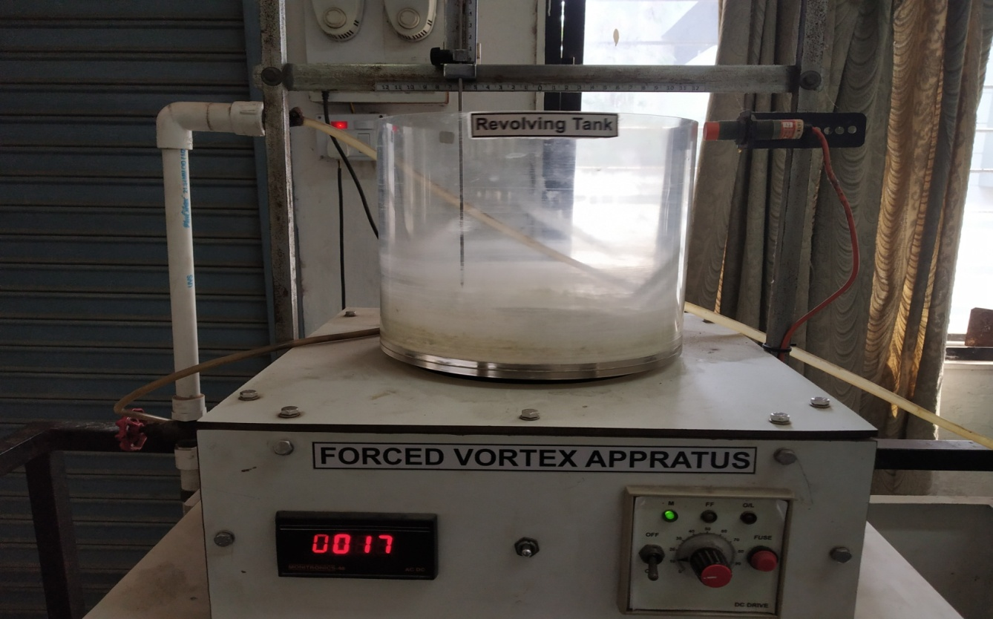
FREE VORTEX APPARATUS
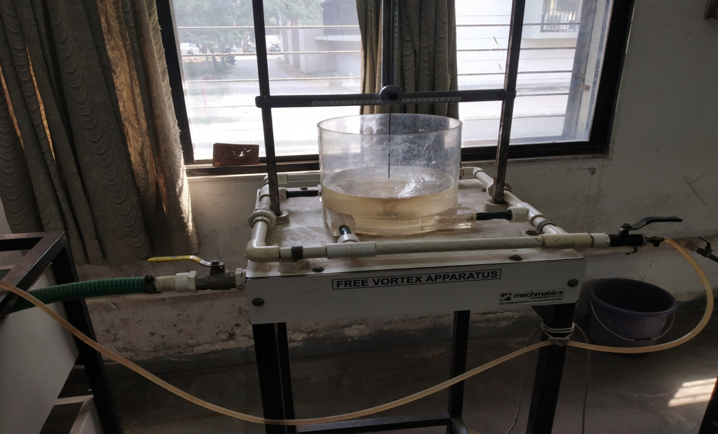

VENTURI/ORRIFICE METER
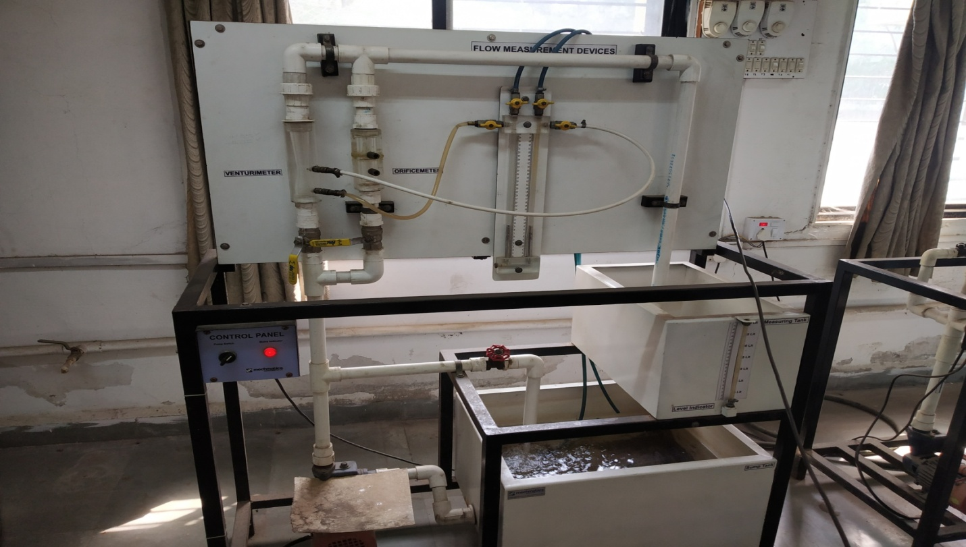
GROUND FLOW/WELL ABSTRACTION
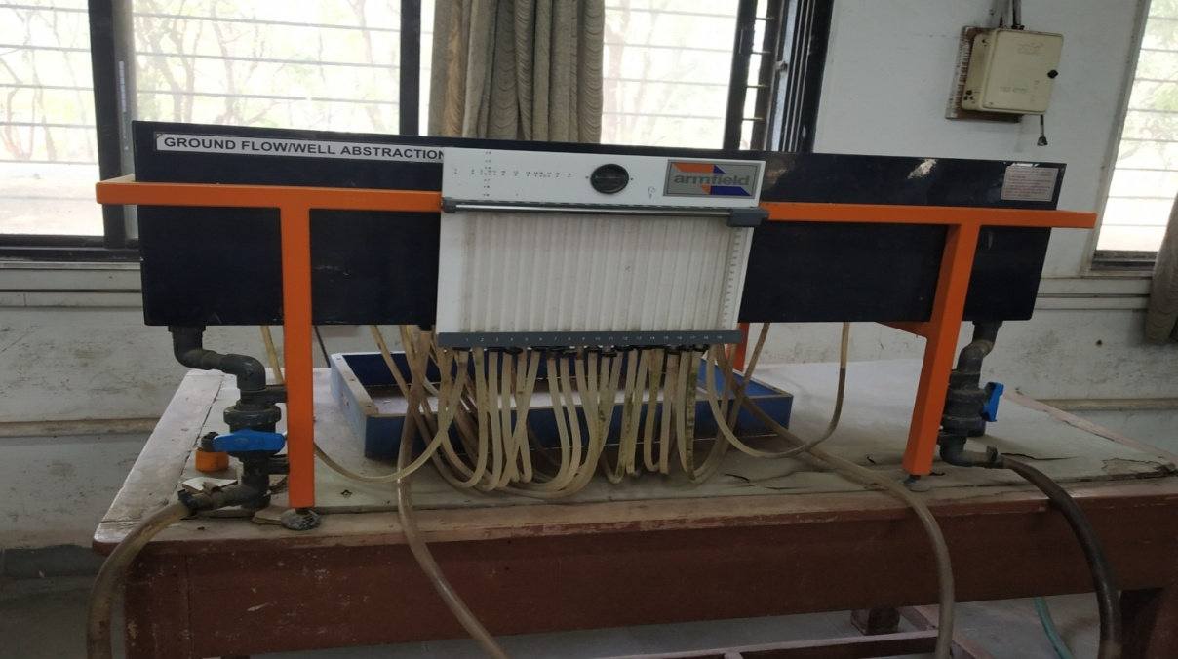
Cavitation Demonstration
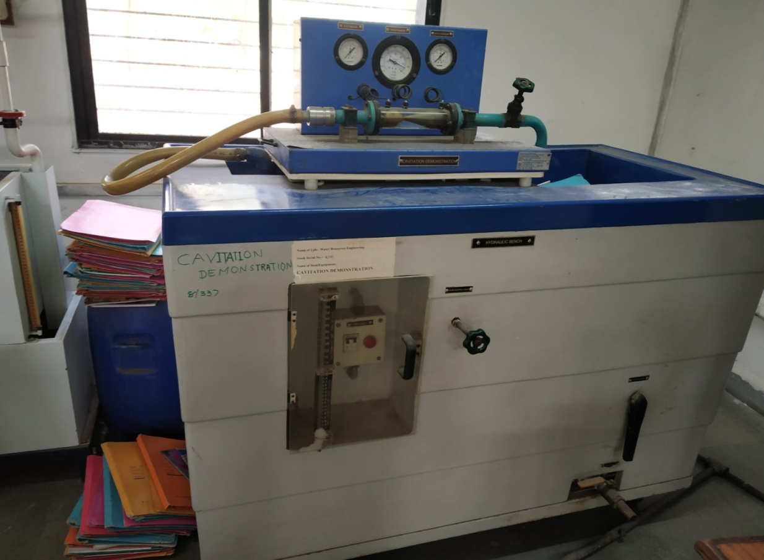

HAMMER WATER APPARATUS
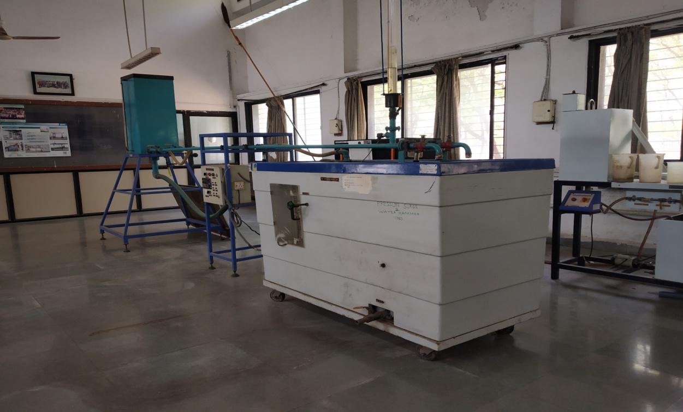
ELECTRICAL ANALOGY APPARATUS
